**Algebra IA: Semester 2 Review Packet Name:___________________**

Unit 2B: Problem Solving with One Variable Equations

Key Topics: Solving Equations and Proportions

**Solve each equation. If the equation is an identity, write identity. If it has no solution, write no solution.**

1) -3 + 5x = 12 2) + 6 = -2 3) = + 4

4) -2(3n – 4) = -10 5) -(5a + 6) = 2(3a + 8)

Solve by writing an equation.

6) There were 150 students at a dance. There were 16 more boys than girls. How many boys were there?

7) Kim walked twice as far as Paula. The sum of the distances they walked is 12 km. How far did each walk?

8) Six less than a number is 9. Find the number.

9) Eleven more than twice a number x is 35. Find the number.

**Solve each word problem.**

10) An orange has 30 more calories than a peach. Thirteen peaches have as many calories as 7 oranges. Find the number of calories in each.

|  |  |  |  |
| --- | --- | --- | --- |
|  | # of fruit X calories per piece = total calories | | |
|  |  |  |  |
|  |  |  |  |

11.) Terry has 7 more quarters than dimes and has a total of $5.95. How many quarters and dimes does he have?

|  |  |  |  |
| --- | --- | --- | --- |
|  | # of coins X $ per coin = total $ | | |
|  |  |  |  |
|  |  |  |  |

12) Three times a number, decreased by 8, is the same as twice the number, increased by 15. Find the number.

13) Lyle shot three times as many baskets as Cliff, while Kyle shot 12 more baskets than Cliff. If Lyle and Kyle shot the same number of baskets, how many baskets did each of them shoot?

14) Burt’s Burger Barn sold 495 hamburgers today. The number sold with cheese was half the number sold without cheese. How many of each kind were sold?

Unit 3: Introductions to Functions

Key Topics: Linear, Quadratic, and Exponential Functions and Relations

1) $\left\{\left(-2,4\right),\left(-1,1\right), \left(0,0\right), \left(1,1\right), (2,4)\right\}$

a) Draw a mapping diagram b) Identify the domain

c) Identify the range

d) Is it a function? Why or why not?

2) $\left\{\left(-5,0\right), \left(5,1\right), \left(-5, 2\right), \left(8, 3\right), (9, -4)\right\}$

a) Draw a mapping diagram b) Identify the domain

c) Identify the range

d) Is it a function? Why or why not?

3) f(x) = 3x – 5 , x = {-3,-2,-1,0,1,2,3}

a) Draw a mapping diagram b) Identify the domain

c) Identify the range

d) Is it a function? Why or why not?

4) f(x) = x² + 1 , x = {-3,-2,-1,0,1,2,3}

a) Draw a mapping diagram b) Identify the domain

c) Identify the range

d) Is it a function? Why or why not?

5) A student’s earnings E, in dollars, is a function of the number h of hours worked. The function is represented by the table below.

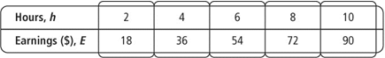

a) Graph the function. b) Is the function linear, exponential or quadratic?

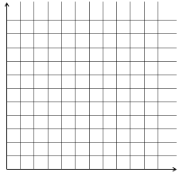

6) Draw an example of linear, quadratic, and exponential function.

7) g(x)= -x2+8

**a.)**  **Evaluate the function at the given values.                       b.)  Graph the function.**

|  |  |  |
| --- | --- | --- |
| *x* | g(x)=-x2+8 | *g*(*x*) |
| -3 |  |  |
| -2 |  |  |
| -1 |  |  |
| 0 |  |  |
| 1 |  |  |
| 2 |  |  |
| 3 |  |  |

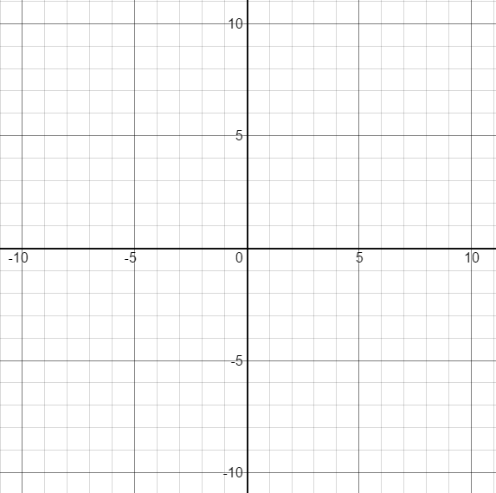

**c.)   Identify the graph as linear, quadratic, exponential, or other.**

**Then describe the key features of the function:**

**d.) Does the graph have any x-intercepts?             How many?**

**e.) Identify the y-intercept:**

**f.) For x-values that are less than 0, is the graph increasing or decreasing?**

**g.) For x-values that are greater than 0, is the graph increasing or decreasing?**

**h.)  Does the graph have a minimum value of the function?               If so, what is it?**

**i.)  Does the graph have a maximum value of the function?               If so, what is it?**

**j.)  Identify the vertex?**

8.) h(x)= 2x - 1

**a.)**  **Evaluate the function at the given values.                       b.)  Graph the function.**

|  |  |  |
| --- | --- | --- |
| *x* | h(x)=2x - 1 | h(x) |
| -2 |  |  |
| -1 |  |  |
| 0 |  |  |
| 1 |  |  |
| 2 |  |  |
| 3 |  |  |



**c.)   Identify the graph as linear, quadratic, exponential, or other.**

**Then describe the key features of the function:**

**d.) Does the graph have any x-intercepts?             How many?**

**e.) Identify the y-intercept:**

**f.)  Is the graph increasing or decreasing?**

**g.) Does the graph have a minimum value of the function?               If so, what is it?**

**h.)  Does the graph have a maximum value of the function?               If so, what is it?**

**i.)   When you look at the left part of the graph, what is the value that all the values of y approach?**

**j.)  What is the equation for the horizontal asymptote?**

9.) f(x)= 3x – 4

**a.)**  **Evaluate the function at the given values.                       b.)  Graph the function.**

|  |  |  |
| --- | --- | --- |
| *x* | f(x)= 3x - 4 | *f(x)* |
| -6 |  |  |
| -3 |  |  |
| 0 |  |  |
| 3 |  |  |
| 6 |  |  |



**c.)   Identify the graph as linear, quadratic, exponential, or other.**

**Then describe the key features of the function:**

**d.) Identify the x-intercept:**

**e.) Identify the y-intercept:**

**f.) Is the graph increasing or decreasing?**

**Unit 4: Linear Functions**

**Key Topics: Slope, Y-Intercept, Slope-Intercept Form (y = mx + b)**

**Determine the slope of each line.**

1) 2) 3)

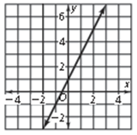 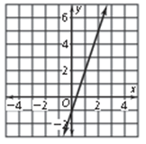 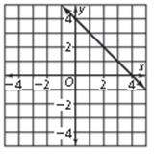

**Determine the slope of each line.**

4) 5) 6)

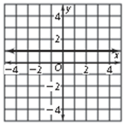 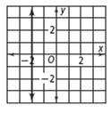 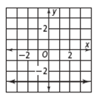

7) What is the slope of the line that passes through the points (2,1) , (0,0)? You can use the blank graph paper to help.

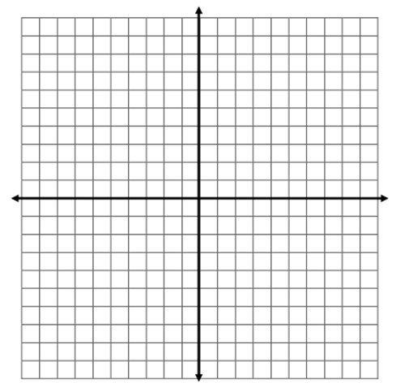

8) What is the slope of the line that passes through the points (3,8) , (7,3)? You can use the blank graph paper to help.



9) What is the slope of the line that passes through the points (-2,-3) , (6,5)? You can use the blank graph paper to help.



**Determine the slope and y-intercept of each equation.**

10) y = 3x + 1 11) y = $\frac{1}{4}$ x – 4 12) y = -5x – 2

slope:_________ slope:_________ slope:_________

y-int:__________ y-int:__________ y-int:__________

13) x = 5 14) y = 5

slope:_________ slope:_________

y-int:__________ y-int:__________

**Write the equation of the line in slope-intercept form (y = mx + b).**

15) 16)

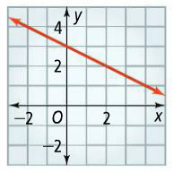 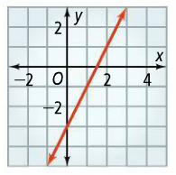

**Write the equation of the line in slope-intercept form that passes through each set of points. you may use the blank graphs to help.**

17) (0,3) and (2,5) 18) (-2,4) and (3,-1) 19) (-3,3) and (1,2)

  

**Unit 5: Scatterplots and Trend Lines**

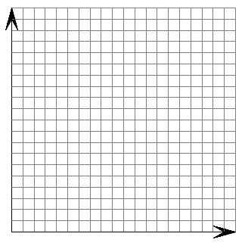**Key Topics: Scatterplots and Trend Lines**

|  |  |  |  |  |  |  |  |  |  |  |  |  |  |  |  |
| --- | --- | --- | --- | --- | --- | --- | --- | --- | --- | --- | --- | --- | --- | --- | --- |
| |  |  | | --- | --- | | **Temperature (C)** | **Volume of Gas (mL)** | | **20** | **63** | | **40** | **65** | | **60** | **68** | | **80** | **74** | | **100** | **81** | | **120** | **86** | | 1. Create a scatterplot using desmos. Draw your scatterplot below and label the scales on the axes. |



1. Describe the association of the scatterplot.

________________________________________________________________________________________________________________________________________________________________________

1. Draw a line of best fit and write the equation.

3. ______________________________________

1. How well does this line fit the data? Be sure to include the correlation coefficient.

________________________________________________________________________________________________________________________________________________________________________

1. Interpret the slope and y-intercept in your equation.

The slope of ________ means that

________________________________________________________________________________________________________________________________________________________________________

The y-intercept of _______ means that

________________________________________________________________________________________________________________________________________________________________________

1. Use your line of best fit equation to make a prediction. What would you expect the volume of gas to be for 140 degrees?

6______________________________________

1. Use your line of best fit equation to make a prediction. Suppose the volume of gas is 45 mL, what would you expect the temperature to be?

7______________________________________

**Unit 6 - Systems of Linear Equations:**

1. Solve the following system of equations by graphing



2. Solve the following systems of equations

a)  b) 

3. What are the possible outcomes when solving a system of two equations and two unknowns?

4. What are the possible techniques to solve a system of two equations and two unknowns?

5. Write the equation of the line that is **parallel** to the given equation and contains the given point.

a.) y = 32x – 4;  (-4, 5)                      b.) y + 2x=3; (3,  1)

6. Write the equation of the line that is **perpendicular** to the given equation and contains the given point.

a.) y = 14x - 3; (2, 10)                b.) y + 3x = 5;  (9, 2)

Answers:

**Unit 2:**

1. x = 3
2. x = -32
3. x = -15
4. n = 3
5. a = -2
6. 67 boys
7. 4 km

8 km

1. x = 15
2. x = 12
3. Orange: 65 calories

Peach: 35 calories

1. 12 dimes

19 quarters

1. x = 23
2. Cliff: 6

Lyle: 18

Kyle: 18

1. 165 with cheese

330 without cheese

**Unit 3:**

1. a)

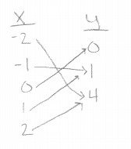

b) 

c) 

d) yes, each x value goes to one y value

2. a)

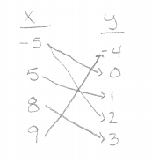

b) 

c) 

d) No, the value of -5 goes to two different y values

3. a)

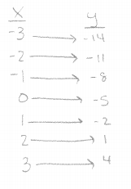

b) 

c) 

d) yes, each x value goes to one y value

4. a)

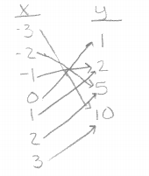

b) 

c) 

d) yes, each domain goes to only one range.

5. a)

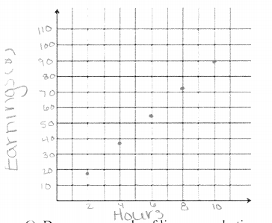

b) Linear

6. 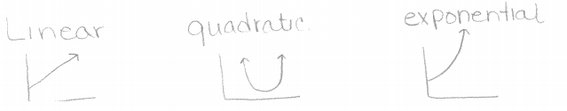

7. a) (-3,-1); (-2, 4); (-1, 7); (0, 8); (1, 7); (2, 4); (3, -1)

b)

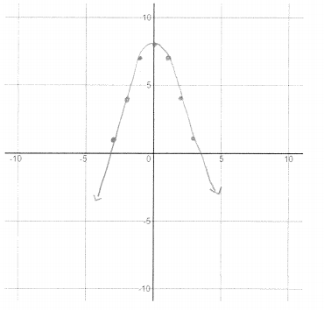

c) Quadratic

d) yes, 2

e) (0, 8)

f) Increasing

g) Decreasing

h) no; NA

i) yes; 8

j) (0, 8)

8. a) (-2, -3/4); (-1, -1/2); (0,0); (1,1); (2, 3); (3, 7)

b)

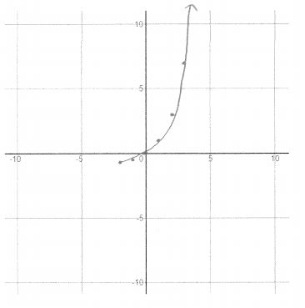

c) exponential

d) yes, 1

e) (0, 0)

f) increasing

g) No, NA

h) No, NA

i) -1

j) y = -1

9. a) (-6, -22); (-3,-13); (0, -4); (3, 5); (6, 14)

b) 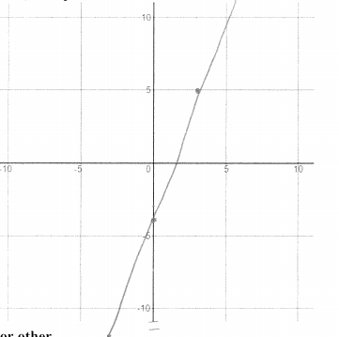

c) Linear

d) about (1 2/3, 0)

e) (0, -4)

f) increasing

**Unit 4:**

1. m = 2
2. m = 3
3. m = -1
4. m = 0
5. m = undefined
6. m = 0
7. m = ½
8. m = -5/4
9. m = 1
10. slope = 3

y –int = (0, 1)

1. slope = 1/4

y –int = (0, -4)

1. slope = -5

y –int = (0, -2)

1. slope = undefined

y –int = none

1. slope = 0

y –int = (0, 5)

1. 
2. 
3. 
4. 
5. 

**Unit 5:**

1. 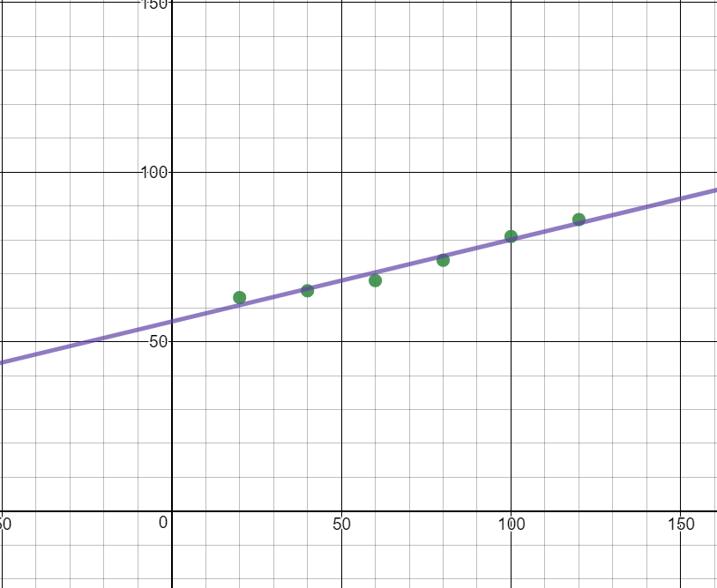
2. Strong positive. As the tempurature increases, the volume of the gas increases.
3. 
4. The line fit the data strongly as the r value is 0.9823.
5. The slope of means that the volume of gas increases by mL for every increase of 1 degree.

The y-intercept of 55.933 means that at a temperature of 0 degrees there will be 55.933 mL of gas.

1. 89.733 mL
2. Approx: -45 degrees

**Unit 6**

1. (-2, 3)

2. a. (-1, 2) b. (3, -1)

3. One solution, no solution, infinite solutions

4. Graphing, substitution, elimination

5. a. y = 32x + 133

b. y = -2x + 7

6. a. 

b. 