Unit 5 Assessment Review-Scatter Plots Name:________________________
ID.B.6: Represent data on two quantitative variables on a scatter plot, and describe how the variables are related.

- Draw 2 examples of each of the following types of scatter plots
- Positive

- Negative

- No correlation

- Draw 2 examples of each of the following types of scatter plots
- Linear

- Quadratic

- Exponential

3. The graph at right represents the amount of money in Mrs. Johnson’s savings account each month in 2015.

- For this data, draw the line of best fit.

- Estimate the equation of the line of best fit:

- How much money would you say was in her account in May, 2015?

- How much money would you estimate will be in her account in February, 2016?

F
2
A4
J
6
A8
O10
D12
$50
$1000
$1500
$2000
$2500
$3000

Hint: January is 1, F= February=2

4. The table below represents the number of people in a new band’s fan club.
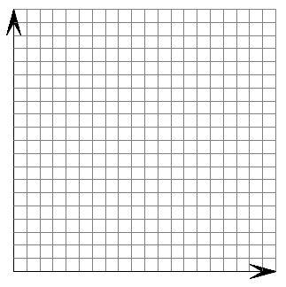
Week | Fans
2 | 1200
4 | 1500
6 | 2400
8 | 2900
10 | 3550
12 | 4400
14 | 5025

- Graph the points on the axes at the right. Label both axes.

- For this data, draw the line of best fit.

- Estimate the equation of the line of best fit:

- How many fans would you predict after 30 weeks?

5. Label each of the following scatterplots as positive, negative, or no correlation.

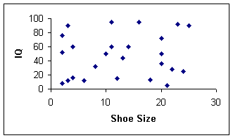
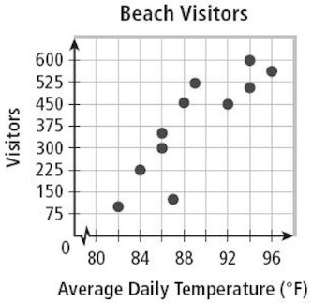
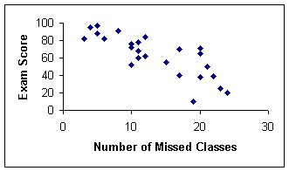

6. The table below represents distance from the bolt to the nut per number of turns.
Number of Turns | Distance from Nut to Bolt Head (mm)
2 | 25
4 | 24
5 | 23
9 | 18
11 | 13
12 | 10

6a) Create a scatterplot. Draw your scatterplot below and label the scales on the axes.

6b) Describe the association of the scatterplot.

6c) Use technology (desmos) to find the equation for the line of best fit and sketch the line on the graph above.

6d) How well does this line fit the data?

6e) Interpret the slope and y-intercept in your equation.
The slope of ________ means that ________________________________________________

The y-intercept of _______ means that _____________________________________________

6f) Use your line of best fit equation to make a prediction. What would you expect the distance from the bolt to the nut to be at 30 turns? What does that say about the linear model for this data?

7. The table below represents the distance of an automobile from Chi-Hi at lunchtime.
Time | Distance  from Chi-Hi (miles)
12:06 | 5
12:08 | 7.5
12:09 | 8
12:10 | 9.5
12:11 | 11
12:12 | 10.5

7a) Create a scatterplot. Draw your scatterplot below and
label the scales on the axes.

7b) Describe the association of the scatterplot.

7c) Use technology to find the equation for the line of best fit and sketch the line on the graph above.

7d) How well does this line fit the data?

7e) Interpret the slope and y-intercept in your equation.
The slope of ________ means that _________________________________________________
The y-intercept of _______ means that ______________________________________________

7f) Use your line of best fit equation to make a prediction. What would you expect distance from Chi-Hi to be at 1:00? If we recorded data for the entire lunch period, how would you expect a linear model fit the data?

7g) Suppose that the car travels 1.5 miles between 12:12 and 12:13. How would that data point change the line of best fit?

Answers:
1.
a. 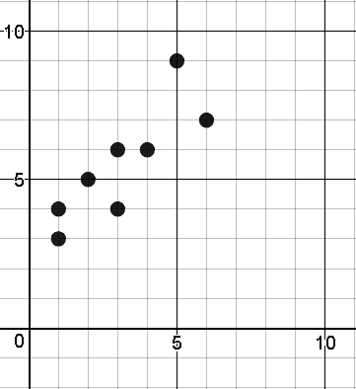
b.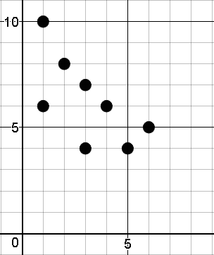
c. 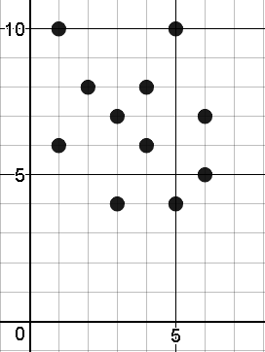
2.
a.
b. 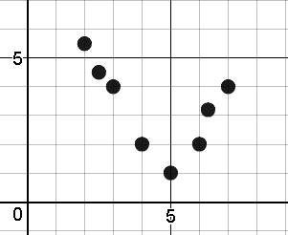
c. 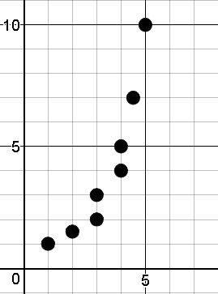
3.
a. 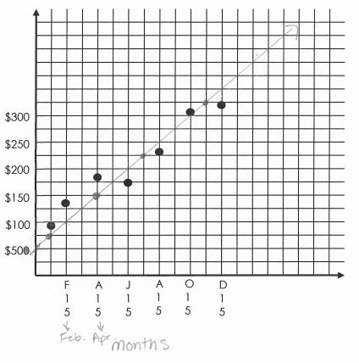
b. y = 25x + 50
c. $175
d. $400
4.
a&b.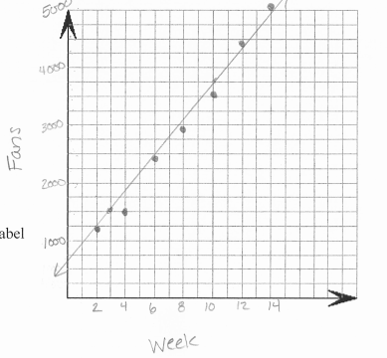
c.
d. approx. 10,200
5. positive, no correlation, negative
6b. The graph has a negative correlation happening. As the number of turns increases, the
distance from nut to bolt head decreases.
c. y = -1.485x + 29.547
d. The line fits the data well as the r value is -0.975 which shows a strong negative correlation
e. The slope of _-1.495__ means that for each increase of 1 turn the distance from nut to bolt head decreases by 1.495 mm. The y-intercept of 29.547 means that if there are zero turns the distance from nut to bolt head would
be 29.547.
f. -15.303, this means that the linear model only works up to a certain number of turns because the
distance cannot be negative.
7. Note: For the graph I chose to put the time into decimal form. So 12:06 was put in as 12.1. You could
also choose to put the time as minutes after the bell which will change any calculations. Both would be
acceptable.
b. The data shows a strong positive correlation. As the time increases the distance from Chi-Hi
also increases.
c. y = 60.008x – 720.85
d. This line fits the data well as the r value is 0.972 which shows a strong positive correlation.
e. The slope of 60.008 means that there is an increase of 60.008 miles for each hour.
The y-intercept of -720.85 means that at midnight the vehicle was a distance of -720.85 miles from
Chi-Hi.
f. 59.254, If we recorded for the entire lunch period a linear model would not be accurate as eventually the
vehicles distance from Chi-Hi will decrease as the students come back to school.
g. By adding in the new data point the slope and y-intercept for the line of best fit decreases.

